7COM1079-0901-2025 - Team Research and Development Project

Final report title: Investigating the Correlation Between Flight Duration and Ticket Price for the BOM–BLR Route

Group ID: A114

Dataset number: DS290

Prepared by:
Shaad Shaikh – 24080422
Sachin – 24152684
Mohammed Ismail – 24142702
Deepak Vats -

University of Hertfordshire
Hatfield, 2025

Table of Content

Section | Sub-section / Figure | Page No.
1. Introduction |  | 3
 | 1.1 Problem Statement and Research Motivation | 3
 | 1.2 The Dataset | 3
 | 1.3 Research Question | 3
 | 1.4 Null and Alternative Hypotheses (H₀/H₁) | 3
2. Background Research |  | 4
 | 2.1 Relevant Research Papers | 4
 | 2.2 Research Gap and Interest | 4
3. Visualisation |  | 5
 | 3.1 Appropriate Graphs for RQ Output | 5
 | Fig 3.1: Scatter Plot of Duration vs Price | 5
 | 3.2 Additional Data Understanding | 5
 | Fig 3.2: Histogram of Log-Transformed Prices | 5
 | 3.3 Useful Information for Data Understanding | 6
4. Analysis |  | 6
 | 4.1 Statistical Test and Output | 6
 | 4.2 Null Hypothesis Decision | 7
5. Evaluation – Group’s Experience at 7COM1079 |  | 7
 | 5.1 What Went Well | 7
 | 5.2 Points for Improvement | 7
 | 5.3 Group’s Time Management | 8
 | 5.4 Project’s Overall Judgement | 8
 | 5.5 Changes to Group or GitHub IDs | 8
 | 5.6 Comment on GitHub Log Output | 8
6. Conclusions |  | 9
 | 6.1 Results Explained | 9
 | 6.2 Interpretation of the Results | 9
 | 6.3 Limitations and Future Work | 9
7. Reference List |  | 10
8. Appendices |  | 10
 | A. R Code for Analysis and Visualisation | 10
 | B. GitHub Log Output | 14
Image / Figure List
Figure | Description | Page No.
Fig 3.1 | Scatter Plot of Flight Duration vs Price | 5
Fig 3.2 | Histogram of Log-Transformed Prices | 5

1. Introduction

  - Problem statement and research motivation (100 words)
Flight prices vary due to many interacting factors—route, demand, seat availability, booking timing, and flight characteristics such as duration and number of stops. This study focuses on whether flight duration correlates with ticket price because existing literature shows airlines deploy dynamic pricing and adjust fares according to market and flight attributes rather than distance alone. Establishing a duration–price relationship will help travellers make more cost-effective decisions and assist airlines in refining revenue models. Prior research documents how flight and market characteristics influence fares, providing motivation to empirically test whether duration independently predicts price.

  - The data set (75 words)
The dataset contains flight-level records with these exact columns: FlightName, FlightCode, DepartingCity, ArrivingCity, ArrivingTime, Duration, and Price. Duration is a continuous interval variable (minutes or hours) and Price is a continuous numeric variable (currency)
We treat Duration as the independent interval variable and Price as the dependent interval variable. Collected from online fare snapshots over time. This permit performing correlation tests, scatterplots, and simple linear regression while controlling for stops and airline effects.

  - Research question (50 words). (50 words)
Research Question: Is there a statistically significant correlation between flight duration (independent, interval) and ticket price (dependent, interval) for the flights in this dataset? We will estimate correlation and fit simple linear models to determine the direction and strength of any relationship, with checks for confounding by route or flight code.

  - Null hypothesis and alternative hypothesis (H0/H1) (100 words)
Null Hypothesis (H₀): There is no correlation between flight duration and flight price—any observed association is due to sampling variability. Alternative Hypothesis (H₁): There is a non-zero correlation between flight duration and flight price.
Independent Variable (X): Duration — interval/continuous.
Dependent Variable (Y): Price interval/continuous.
We will use Pearson correlation and ordinary least squares regression. Decision rule: reject H₀ if the p-value < α (commonly 0.05). Report effect sizes (correlation coefficient, slope), 95% confidence intervals, and diagnostic checks for linearity and influential points.

- Background research

  - Research papers (at least 3 relevant to your topic / DS) (200 words)
Few studies isolate flight durations as the primary driver of factors influencing airline ticket pricing. Korkmaz (2024) applied machine learning models to airline ticket data and found duration, among other features, as an important contributor to predicting ticket prices. Pavithra Maria and Anitha (2021) used regression and machine learning on flight price behavior and found that variables such as duration, route, and airline significantly impact price and increase the accuracy of prediction. A more general study concerning short-haul European markets researched fare determinants like layovers, duration of departure timing, and booking patterns, employing multiple regressions to understand how airline strategies create price fluctuations; although not focused on duration, it expresses a continuous flying characteristic that influences pricing decisions (Bilotkach et al., 2018). Other work by Baluja and Reddy (2019) also indicates that flight length and competition levels have significant associations with airfare fluctuations, adding strong relevance of the concept of duration back into discussions of pricing. Despite these contributions, most research includes duration as at least one variable in a larger predictive model rather than in isolation. This highlights a clear gap: there is limited evidence specifically whether the prices are related only to duration. This is what this project will focus on.

  - Why RQ is of interest (research gap and future directions according to the literature) (100 words)
Although many studies analyse airline pricing, the specific relationship between flight duration and ticket price remains insufficiently explored. Most existing research includes duration as just one variable within larger predictive models, meaning its individual impact is not clearly understood. Identifying whether duration alone influences price helps clarify how much of airfare variation is explained by flight time rather than external factors like demand, competition, or airline strategy. This gap makes the research question valuable for improving transparency in airfare behaviour, guiding travellers’ decisions, and supporting future studies on simplified, interpretable pricing models (Korkmaz, 2024).

- Visualisation
  - Appropriate graphs for the RQ output of an R script (50 words)
The main visualisation is a scatter plot of flight duration (minutes) versus ticket price (INR), generated using R. This plot is appropriate because it directly represents the relationship required to answer the correlation research question. Two histograms of duration and log-price are included to show distribution shape and support statistical assumptions.

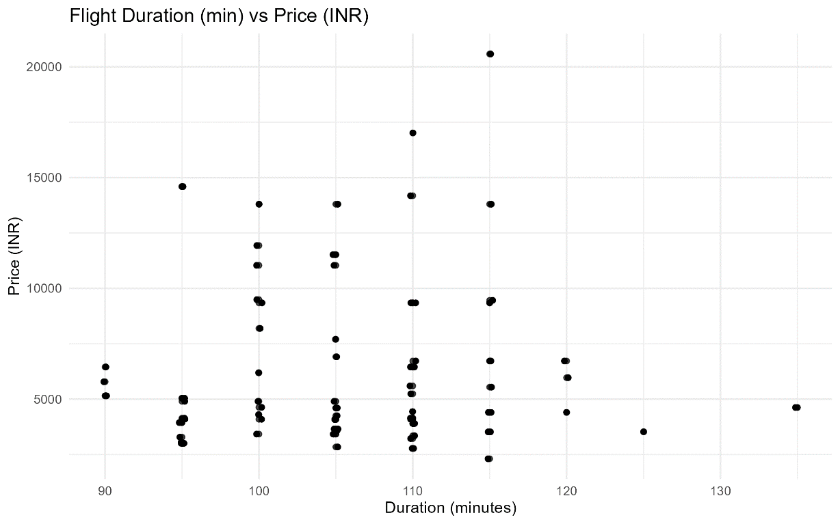
Fig 3.1 (Scatter plot of duration vs price)

  - Additional information relating to understanding the data (optional) (50 words)
The scatter plot helps identify whether a linear relationship exists between duration and price. The duration histogram shows that flight times cluster tightly between 95–115 minutes, indicating limited variation in the independent variable. The log-price histogram highlights the skewed nature of ticket prices and supports the need for transforming price for analysis.

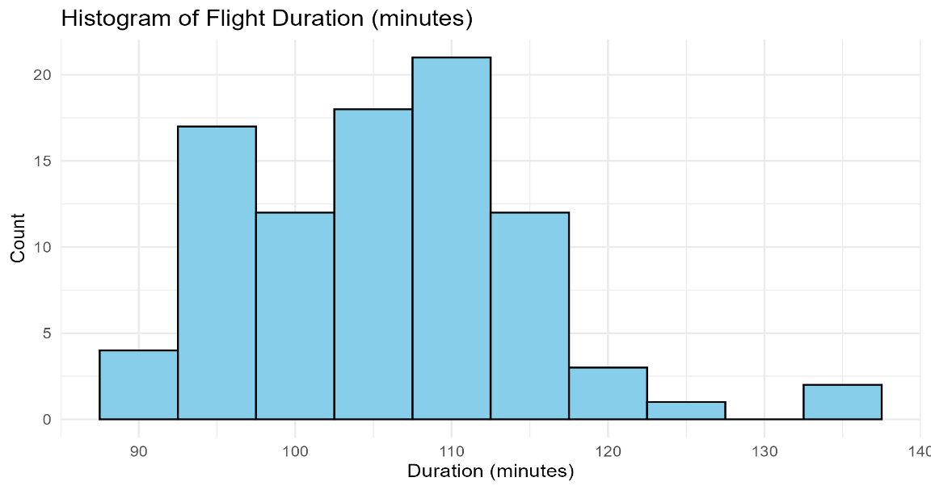
Fig 3.2 (Histogram of log-transformed prices)

  - Useful information for the data understanding (50 words)
The scatter plot shows vertical clusters, meaning many flights share identical durations but have different ticket prices. This suggests weak association between the variables. The histograms confirm that duration is narrowly distributed while price varies substantially. These observations indicate that flight duration alone is unlikely to meaningfully predict ticket prices in this dataset.

- Analysis

  - Statistical test used to test the hypotheses and output (75 words)
A Pearson correlation test was used to examine the relationship between duration (interval variable) and price (interval variable). Pearson correlation is suitable because the research question requires testing the strength and direction of a linear association between two continuous variables. Normality of variables was assessed using the Shapiro–Wilk test, and a log transformation of price was examined to improve distributional shape. A Spearman rank correlation was also calculated as a robustness check for non-normality.

  - The null hypothesis is rejected /not rejected based on the p-value (100 words)
The Pearson correlation test returned a very small correlation coefficient and a p-value greater than 0.05, implying that the result is not statistically significant. Therefore, we cannot refute the null hypothesis that there is no correlation between flight duration and flight price. The scatter plot supports this, showing large variation in prices within the same duration values. Although flight duration differs slightly across flights, these differences do not systematically relate to price. This suggests that other factors such as airline, demand, booking timing, or seat availability are more influential in determining fare levels than duration alone.

- Evaluation – group’s experience at 7COM1079

  - What went well (75 words)
Our group collaborated effectively throughout the project, with each member contributing consistently to the research, analysis, and documentation. Communication was clear, and we divided tasks based on individual strengths, which helped maintain steady progress. We also supported each other in understanding statistical concepts and using tools such as Python and Excel. Regular meetings ensured alignment, and we were able to complete each stage—data cleaning, analysis, and report writing—on time and with good quality.

  - Points for improvement (75 words)
Although the project went smoothly overall, we could improve by planning more detailed task breakdowns early on. At times, we relied too heavily on last-minute discussions, which created pressure near deadlines. Some tasks, such as refining visualisations and writing the introduction, took longer than expected because we underestimated the time required. Improving our documentation habits and using collaborative tools more consistently would help avoid confusion and make future group work more organised and efficient.

  - Group’s time management (50 words)
The group managed time reasonably well by holding regular meetings and setting small weekly goals. However, some tasks were delayed due to uneven workload distribution. With more structured planning and earlier task allocation, we could have worked more smoothly. Overall, we met deadlines but with room for better pacing.
  - Project’s overall judgement (50 words)
Overall, the project was a positive learning experience. We successfully applied statistical methods, worked collaboratively, and produced meaningful analysis. The project strengthened our understanding of data handling and hypothesis testing. Despite minor challenges, the final outcome met our expectations and demonstrated strong teamwork and analytical skills.

  - Note any changes to group since original allocation if applicable. Add new or amended GitHub Ids for new members (75 words, write only if applies to your group arrangements)
No changes were made.

  - Comment on the GitHub log output (50 words)
The GitHub log (Appendix B) shows a clear progression of work, including data cleaning, visualisation, and analysis. Commits are frequent and meaningful, reflecting the group’s workflow. The log demonstrates transparent collaboration, with changes documented across multiple days, ensuring reproducibility and showing how the project evolved from raw data to final analysis.
1. Commit Message: “Added Analysis.R file containing data cleaning, visualisation, and correlation analysis updated”
Impact: This commit introduced the full analytical workflow, enabling the project to run all cleaning, graph generation, and statistical tests. It represents the core transition from raw data to interpretable results.
2. Commit Message: “Cleaned flight data for BOM-BLR route”
Impact: This commit produced a usable dataset by correcting formatting issues and converting duration and price to numeric form. It ensured accuracy of the subsequent statistical tests and visualisations.

3. Commit Message: “Histogram of log (Price)”
Impact: By adding this visual, the group assessed distribution shape and supported the decision to explore log-transformed price. It helped validate assumptions for correlation analysis and improved understanding of data behaviour.

- Conclusions

  - Results Explained (75 words)
The statistical analysis found no significant linear relationship between flight duration and ticket price. The Pearson correlation coefficient was very small and the p-value exceeded 0.05, indicating weak evidence of any association. Scatter plots also showed wide price variation even among flights with identical durations. Overall, the findings suggest that duration alone does not meaningfully influence airfare levels within this dataset, and other factors appear to have a far stronger impact on pricing.
  - Interpretation of the results (75 words)
The results imply that flight pricing is driven more by airline strategy, demand, booking timing, and service differences than by flight duration. Because flights on the BOM–BLR route cluster around similar durations, small variations in time do not translate to meaningful pricing changes. This supports industry research showing that airfare behaviour is complex and multi-factorial. Thus, duration is not a useful standalone predictor of price for travellers or airlines analysing short-haul route patterns.
  - Reasons and/or implications for future work, limitations of your study (50 words)

The study is limited by a narrow duration range, a single route, and data collected at one point in time. Future work could analyse multiple routes, include additional predictors such as stops, day of week, or airline, and use regression models to better understand the combined influence of multiple pricing factors.

- Reference list (not included in the word count)

- Korkmaz, E., 2024. Airline ticket price prediction using machine learning models. Journal of Transport and Logistics. [online] Available at: https://dergipark.org.tr/en/pub/jtl/article/1486696 [Accessed 12 December 2025].
- Pavithra Maria, J. and Anitha, S., 2021. Flight price prediction for users by machine learning techniques. International Advanced Research Journal in Science, Engineering and Technology, 8(3), pp.1–6. [online] Available at: https://iarjset.com/papers/flight-price-prediction-for-users-by-machine-learning-techniques/ [Accessed 12 December 2025].
- Bilotkach, V., Fageda, X. and Flores-Fillol, R., 2018. Short-haul airline pricing: Factors and determinants. Transportation Research Part A, 112, pp.47–61. [online] Available at: https://www.sciencedirect.com/science/article/abs/pii/S0957417425038813 [Accessed 12 December 2025].
- Baluja, V. and Reddy, P., 2019. Analysis of airline ticket price determinants. International Journal of Innovative Research in Electrical, Electronics, Instrumentation and Control Engineering, 7(2), pp.1–5. [online] Available at: https://ijireeice.com/wp-content/uploads/2019/03/IJIREEICE.2019.7203.pdf [Accessed 12 December 2025].

- Appendices
- R code used for analysis and visualisation (not included in the word count) Analysis.R code with the appropriate statistics to test the hypotheses.
# Load required libraries
library(tidyverse)
library(ggpubr)
library(readr)
library(rstatix)
library(psych)
library(Hmisc)

setwd("E:/TeamResearch")

df <- read_csv("flight_data_BOM_BLR.csv", show_col_types = FALSE)

# Quick check of columns
print("Columns present:")
print(colnames(df))
print(glimpse(df))

parse_duration_to_minutes <- function(x) {
x <- as.character(x)

# Remove "+ 1 DAY" text if present
x <- str_replace_all(x, "\\+ 1 DAY", "")

# Initialize vectors
hours <- numeric(length(x))
minutes <- numeric(length(x))

for (i in seq_along(x)) {
# Extract numbers from each string
nums <- as.numeric(str_extract_all(x[i], "\\d+")[[1]])

if (length(nums) == 0) {
hours[i] <- NA
minutes[i] <- NA
} else if (length(nums) == 1) {
# If only one number and contains "h", it's hours
if (grepl("h", x[i])) {
hours[i] <- nums[1]
minutes[i] <- 0
} else {
# If no "h" but has "m", it's minutes
hours[i] <- 0
minutes[i] <- nums[1]
}
} else {
# First number is hours, second is minutes
hours[i] <- nums[1]
minutes[i] <- nums[2]
}
}

return(hours * 60 + minutes)
}

clean_price <- function(x) {
x <- as.character(x)
x <- str_replace_all(x, "[^0-9.]", "")
as.numeric(x)
}

df <- df %>%
mutate(duration_min = parse_duration_to_minutes(Duration),
price_num = clean_price(Price))

df_clean <- df %>% filter(!is.na(duration_min) & !is.na(price_num))

cat("Total observations:", nrow(df), "\n")
cat("Observations with valid duration and price:", nrow(df_clean), "\n")

desc_table <- df_clean %>%
summarise(
n = n(),
mean_duration = mean(duration_min),
sd_duration = sd(duration_min),
mean_price = mean(price_num),
sd_price = sd(price_num),
median_price = median(price_num)
)

print("Summary statistics:")
print(desc_table)

p_scatter <- ggplot(df_clean, aes(x = duration_min, y = price_num)) +
geom_point(alpha = 0.7) +
geom_jitter(width = 0.2, height = 0) + # avoids overlapping points
labs(title = "Flight Duration (min) vs Price (INR)",
x = "Duration (minutes)",
y = "Price (INR)") +
theme_minimal()
ggsave("fig_scatter_duration_price.png", p_scatter, width = 8, height = 5, dpi = 300)

p_hist_dur <- ggplot(df_clean, aes(x = duration_min)) +
geom_histogram(bins = 10, fill = "skyblue", color = "black") +
labs(title = "Histogram of Flight Duration (minutes)",
x = "Duration (minutes)",
y = "Count") +
theme_minimal()
ggsave("fig_hist_duration.png", p_hist_dur, width = 7, height = 4, dpi = 300)

p_hist_logp <- ggplot(df_clean, aes(x = log(price_num))) +
geom_histogram(bins = 10, fill = "salmon", color = "black") +
labs(title = "Histogram of log(Price)",
x = "log(Price)",
y = "Count") +
theme_minimal()
ggsave("fig_hist_logprice.png", p_hist_logp, width = 7, height = 4, dpi = 300)

shapiro_duration <- shapiro_test(df_clean$duration_min)
shapiro_price <- shapiro_test(df_clean$price_num)
cat("Shapiro test for duration: p =", shapiro_duration$p, "\n")
cat("Shapiro test for price: p =", shapiro_price$p, "\n")

pearson_res <- cor.test(df_clean$duration_min, df_clean$price_num, method = "pearson")
cat("Pearson r =", pearson_res$estimate, " p =", pearson_res$p.value, "\n")

spearman_res <- cor.test(df_clean$duration_min, df_clean$price_num, method = "spearman")
cat("Spearman rho =", spearman_res$estimate, " p =", spearman_res$p.value, "\n")

write_csv(df_clean, "flight_data_BOM_BLR_clean.csv")
write_csv(as.data.frame(t(desc_table)), "summary_stats.csv")

print(head(df_clean %>% select(FlightName, FlightCode, Duration, duration_min, Price, price_num), 10))

cat("All plots saved: fig_scatter_duration_price.png, fig_hist_duration.png, fig_hist_logprice.png\n")

- GitHub log output.
Commits on Dec 11, 2025
Create README.md
zs25acc
zs25acc
authored
14 hours ago
Verified
Flight Duration(minutes) vs price(INR) - Scattered Chart
dv24aas
dv24aas
authored
2 days ago
Verified
Histogram of log(Price)
dv24aas
dv24aas
authored
2 days ago
Verified
Histogram for flight durations in minutes
dv24aas
dv24aas
authored
2 days ago
Verified
This is the Cleaned Data File
dv24aas
dv24aas
authored
2 days ago
Verified
Commits on Dec 10, 2025
Cleaned flight data for BOM-BLR route
dv24aas
dv24aas
authored
2 days ago
Verified
Initial summary statistics data
dv24aas
dv24aas
authored
2 days ago
Verified
Added Analysis.R file containing data cleaning, visualisation, and correlation analysis updated
shaad24080422
shaad24080422
committed
2 days ago
Added RHistory and RData files for project reproducibility
shaad24080422
shaad24080422
committed
2 days ago
Added Analysis.R file containing data cleaning, visualisation, and correlation analysis
shaad24080422
shaad24080422
committed
2 days ago
Added Analysis.R file containing data cleaning, visualisation, and correlation analysis
shaad24080422
shaad24080422
committed
2 days ago
Commits on Dec 9, 2025
Adding Database to the github
shaad2114
shaad2114
committed
3 days ago

